Five Minutes

for Piano

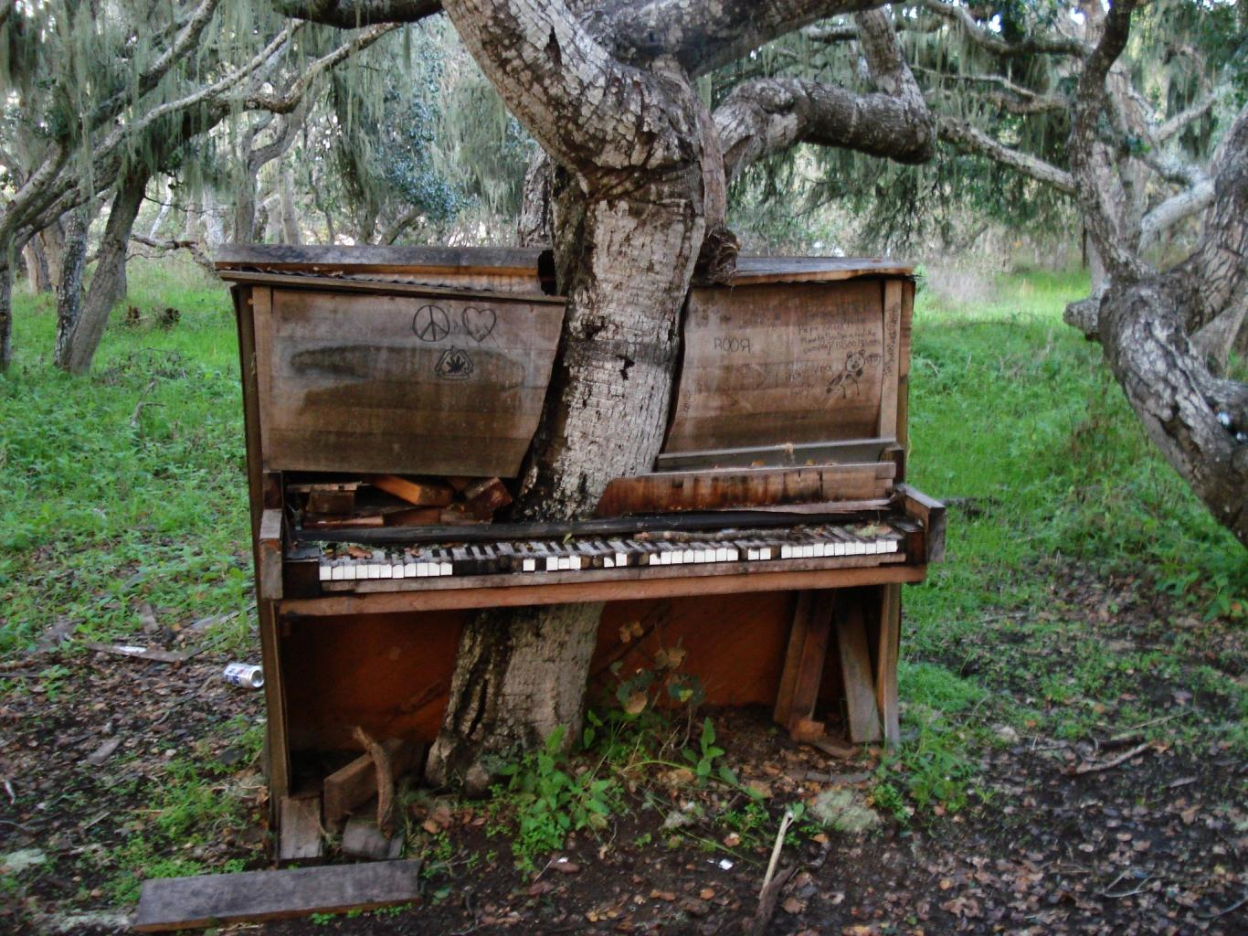

Bill Robinson

