Happy Birthday To Me
for Piano
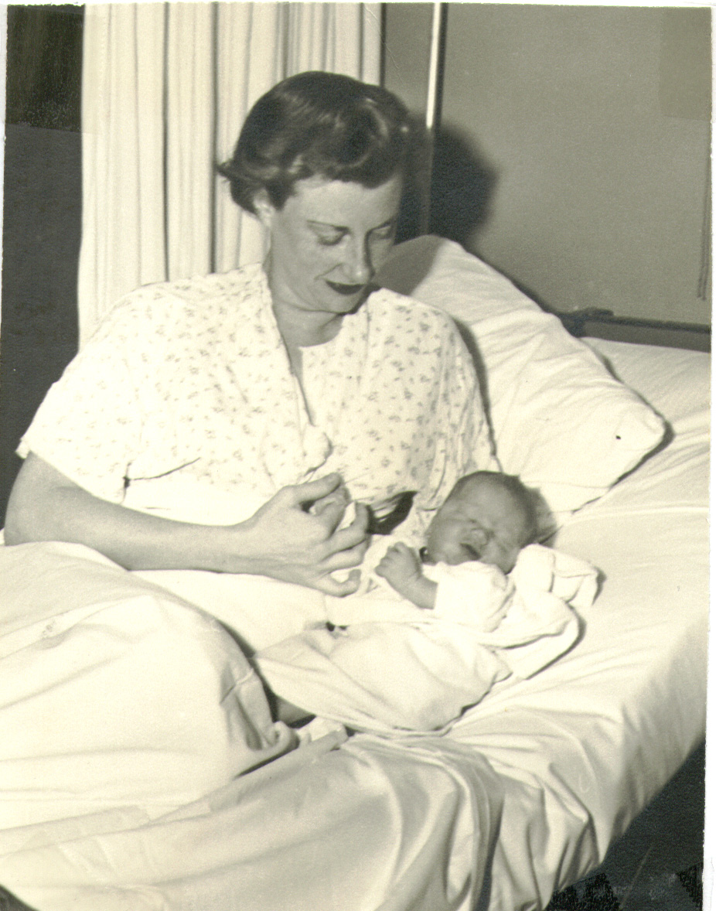
Bill Robinson

