Cello Concerto

Chamber Edition
for Cello and Two Pianos

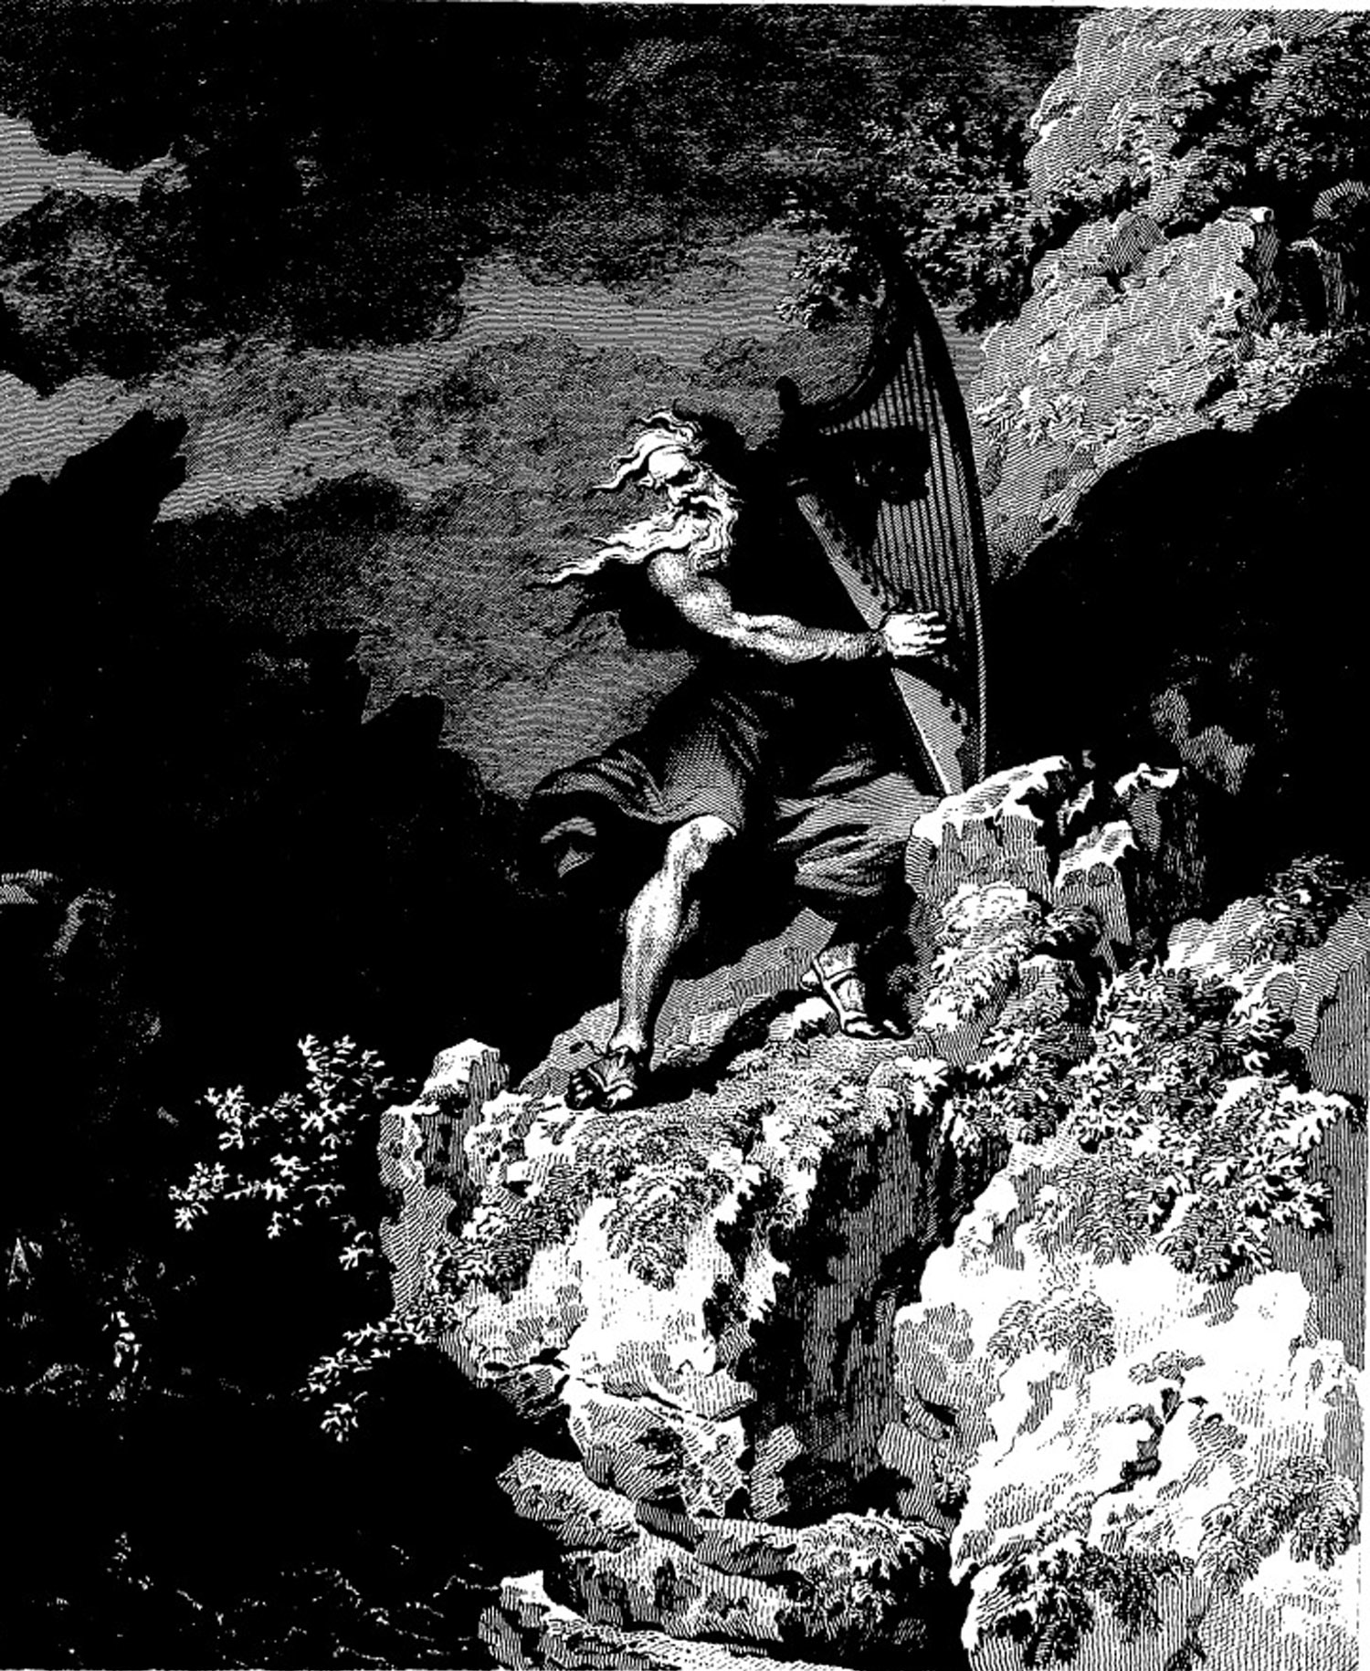

Bill Robinson

