Chamber Concerto

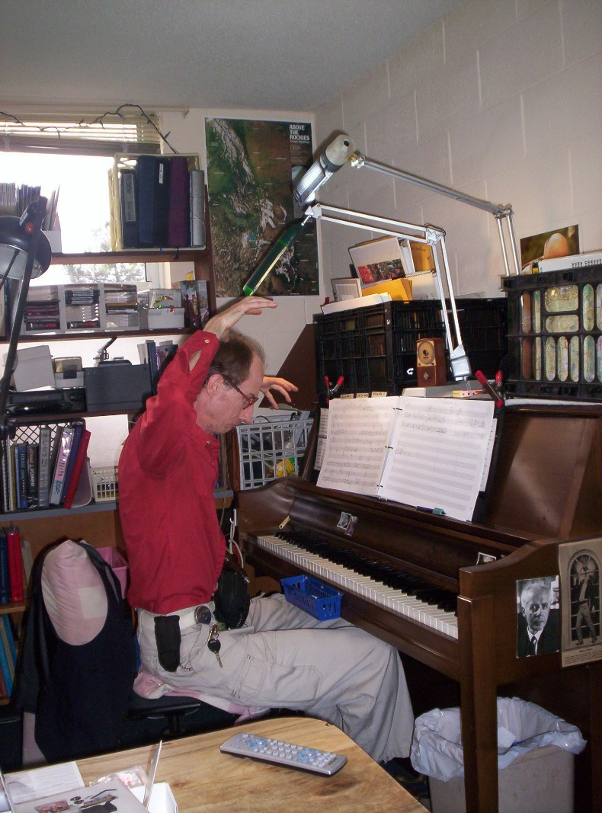
for Piano and
String Quartet

Bill Robinson

