Diatonic Phrygian Tetrachord

for Violin
and Chamber Orchestra
Violin I

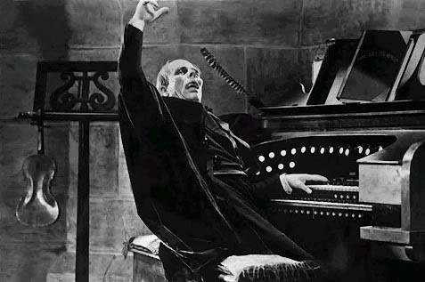

Bill Robinson

