On hearing a friend has died
for String Quartet

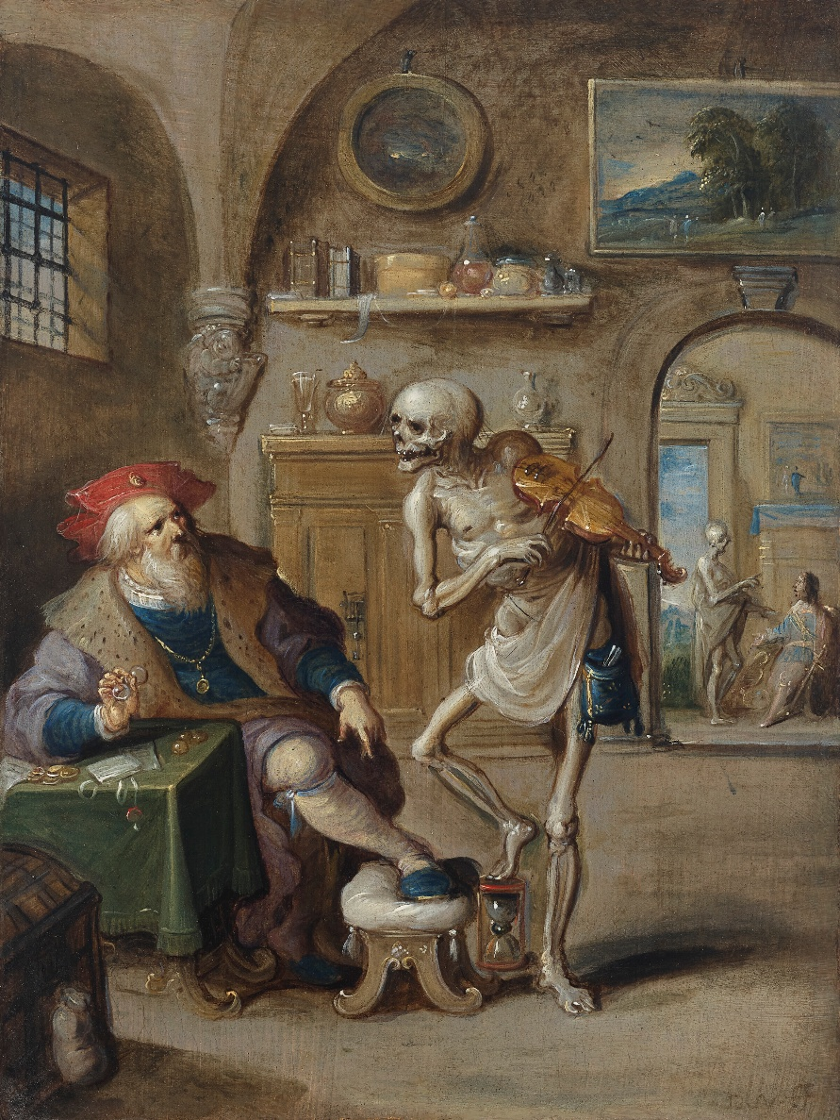

Bill Robinson

