Ten Sonatas for Solo Violin or Viola
Violin Edition

Bill Robinson
Sonatas #1, 9, and 10 edited by Eric Pritchard

These sonatas were written between 1975 and 2003 in a rather complex pattern of starts and stops, composition and disposal, editing and recopying. I wrote a solo violin sonata in the spring of 1975, and based my now-eliminated First Symphony based on its ideas; dissatisfied, I completely re-wrote it in January 1979, saving little from the original. I revised the first movement again in the spring of 1991 and the last movement in 2002. The second sonata came along in 1976, composed for Deborah Moreland’s 18th birthday as a two-movement work. I rewrote both movements in 1991, and in 2002 reversed their order and added a third movement written in 1991. (In addition, in 1975 I wrote a sonata for solo cello or viola, but discarded it later.)
In 1979 I decided to write a total of 64 movements in 21 sonatas for solo violin, correlating each movement to a hexagram of the “I Ching”—not by using chance to determine things, as John Cage did, but just as a kind of unifying device and as an illustration of the nature of each hexagram. As I finished the 21 sonatas, my arthritis became severe enough that I could no longer play violin, and the sonatas remained unperformed.
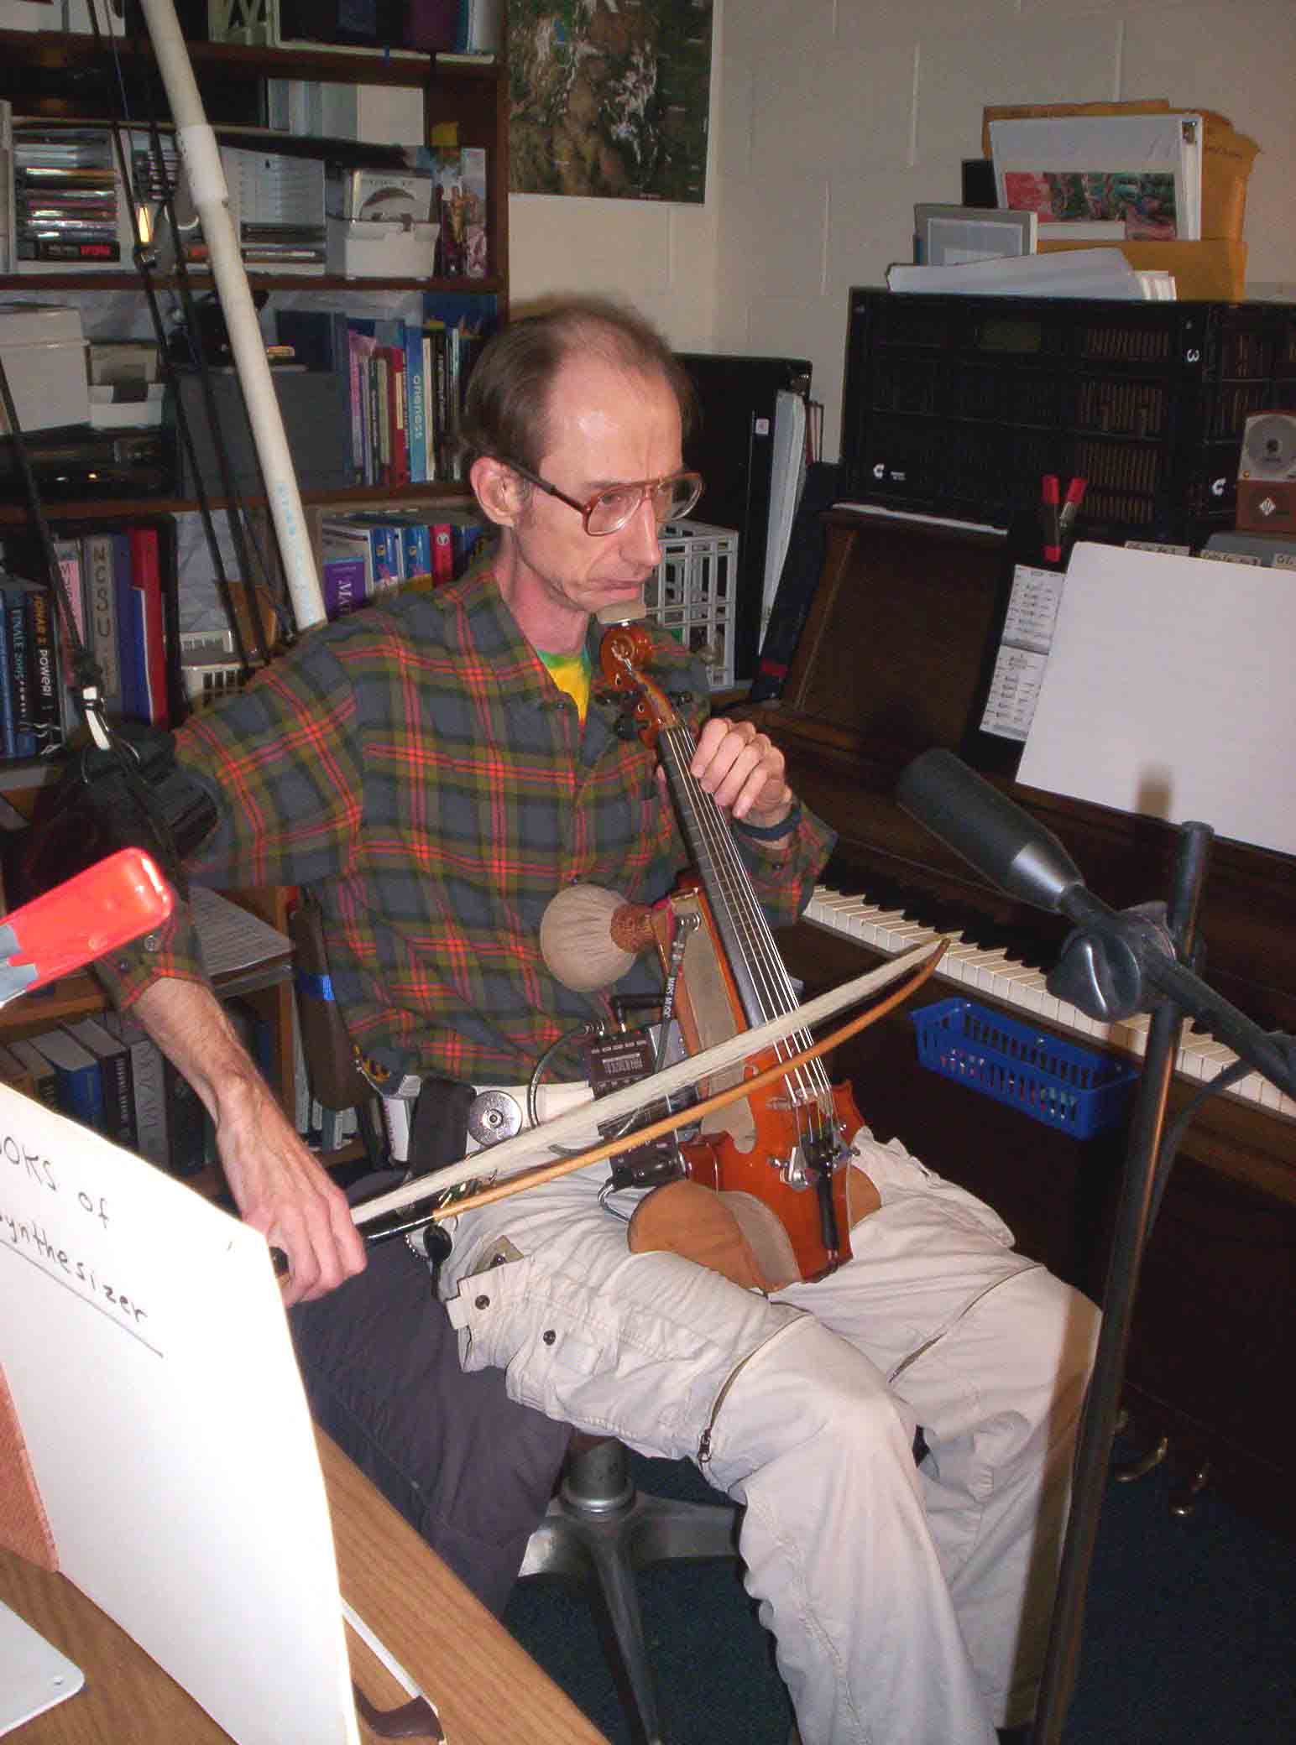
In 1991 I made an electric violin which I used for six months. It appeared that I was going to be able to play again, so I went back to work on the 21 sonatas, throwing out the weaker movements, rewriting those that had promise, and keeping the ones that were fine as they stood. This made the new total of 16 sonatas with about a third completely new material. However after this six month period I was no longer able to play, both physically and due to other complications. At this time, when I was forced to vacate my dwelling, my landlord threw away all my compositions that had been copied in ink.
There followed ten years where making music was not possible. In late 2001 and early 2002, I had a stable life studying physics at NCSU, an old piano, housing, and access to a woodshop. I made two electric violins, a 4-string and a 6-string, that I held like a cello, with an assistive device to hold up my bow-arm. I could only play for a limited time before it became too painful, but the new attempt at performance inspired me to rework once again my old solo violin sonatas, including arrangements for viola and 6-string violin. (I located two copies of the old 21 sonatas that I had given to violinists, returned unperformed, and also recovered pencil drafts from the 1991 revisions—thus recovering from the landlord’s editorial judgment.) This led to once again throwing away weaker movements and a radical re-ordering of the remaining ones in sets of three or four to make eleven sonatas that were reasonably consistent. The grouping is arbitrary, though, and in performance it is perfectly respectable for the violinist to pick whatever movements seem appropriate and play them in the order of his or her choice.
By spring of 2003, it became clear that the arthritis was too advanced and my attempt at a return to performance had to end. In March 2017, a cortisone injection in my right shoulder made it possible to start playing again on 4 and 6 string electric violins with adaptive gear; but this only worked for a few months.
In November 2015 I was making a revision of the copy work and making an experimental arrangement for cello, when I realized that the eighth of the eleven sonatas had two weak movements. I kept only the middle movement, and made what had been #9, 10, and 11 the new #8, 9, and 10, with the old middle movement now the first movement of the new #8. Then in March 2017, I started an arrangement of all 10 sonatas for 6 string violin, leading to major changes in several of the 4 string sonatas and improvement in many details. Previous editions should be discarded.
For page numbers, the number in parentheses is the page in this volume; odd numbers on right pages. This is followed by the sonata number, and the page of that sonata. Thus, for instance,
(6) Sonata #1 page 5
My website billrobinsonmusic.com has all the scores and recordings of each sonata. It will take some time before this second edition is recorded in full.
These violin sonatas are dedicated to Eric Pritchard, the first violinist to appreciate their value and bring them to actual performance.

Publisher Parrish Press May, 2018 2nd Edition Cleveland NC

billrobinsonmusic.com billrobinsonmusic@yahoo.com

