The Three Kinds of Music
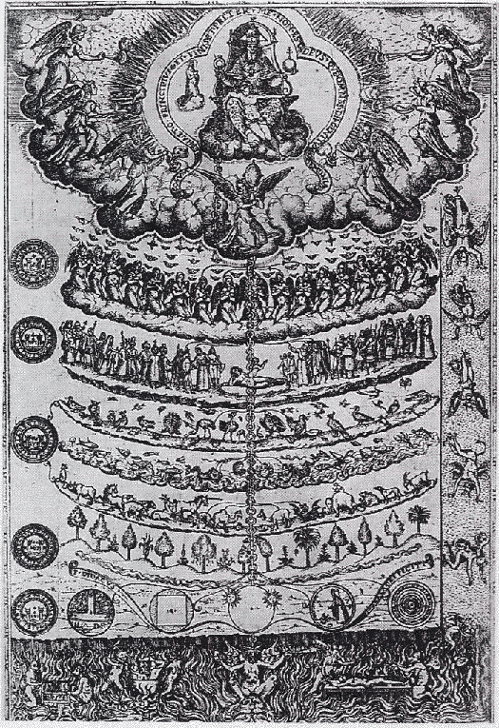
for Violin, Violoncello, and Piano
Violoncello
