Revolution Songs
for Soprano, Violin, Cello, and Piano
to commemorate the 250th Birthday of the United States in 2026

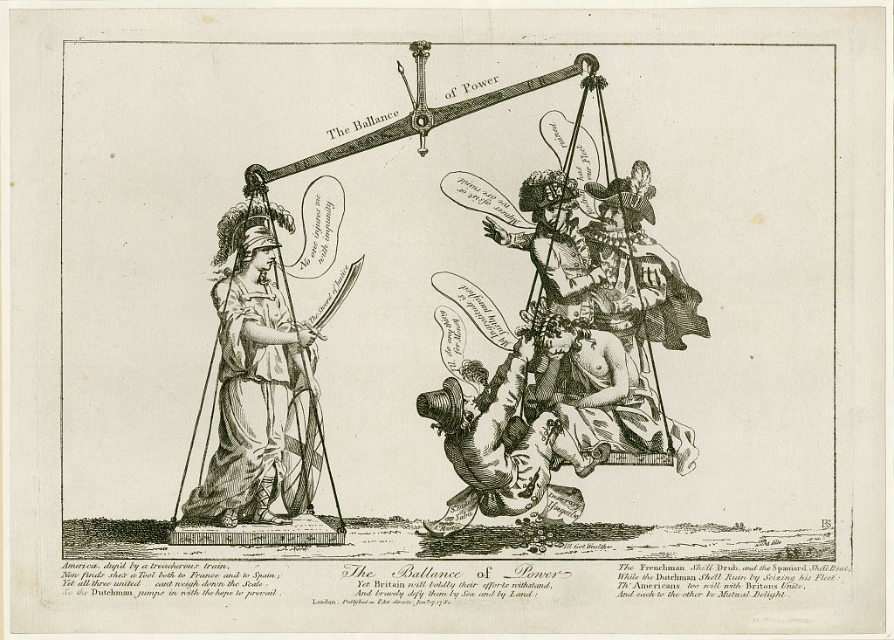

Lyrics and/or melodies by Jonathan Odell, John H. Hewitt, Gaetano Donizetti, traditional tunes, and anonymous screeds

Music by Bill Robinson

