Burlesque

for Concert Band

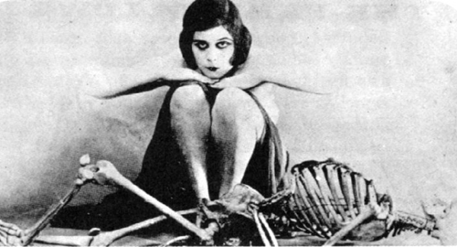

Bill Robinson

