For Those Who Fell:
A War Memorial
for
Concert Band

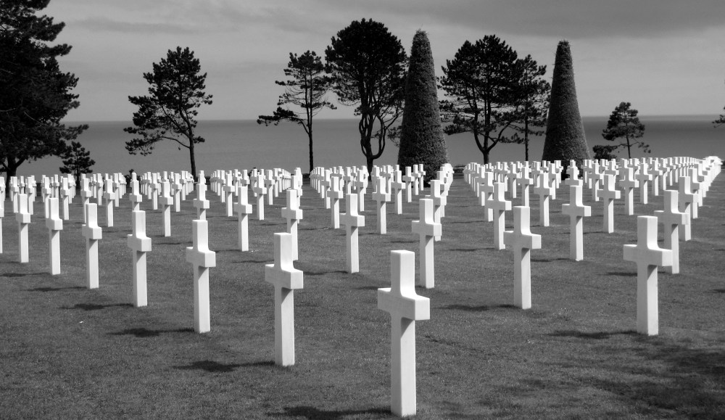

Bill Robinson

