Miniatures

for Woodwind Quintet and Piano

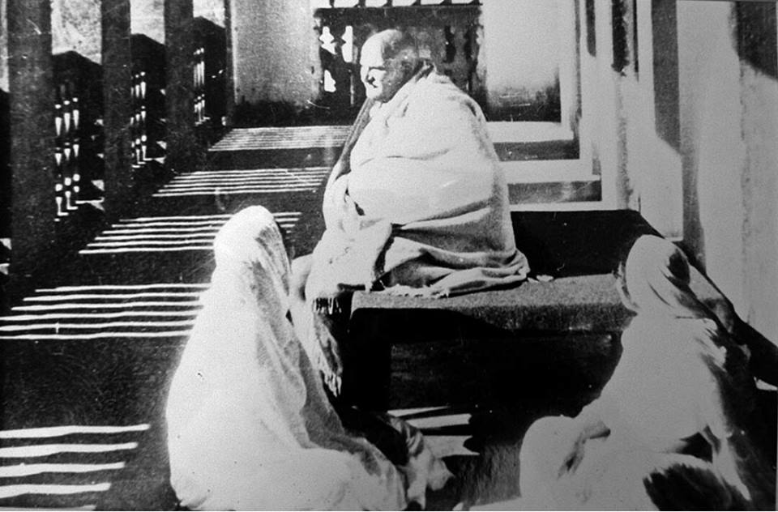

Bill Robinson

