Polytonalmodalyodel

for Concert Band

Clarinet 1
in B flat

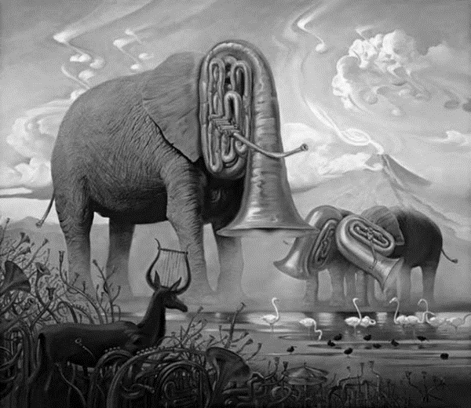

Bill Robinson

