A Little Poem

for Concert Band

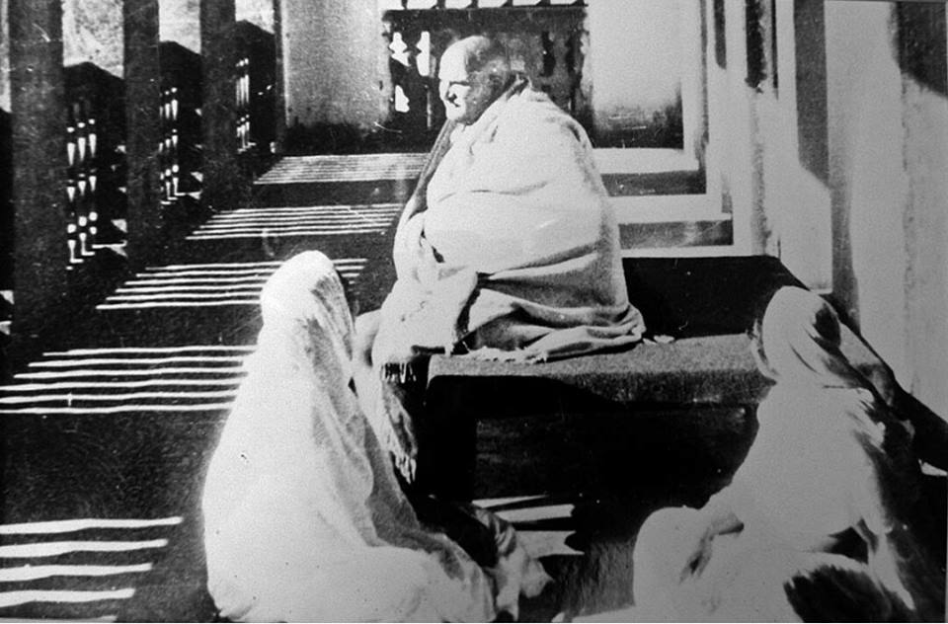

Bill Robinson

